Name: Hew Joe-Vi

Class: 1k5

**CS task 3 (pentaksiran 4)**

Step 1:

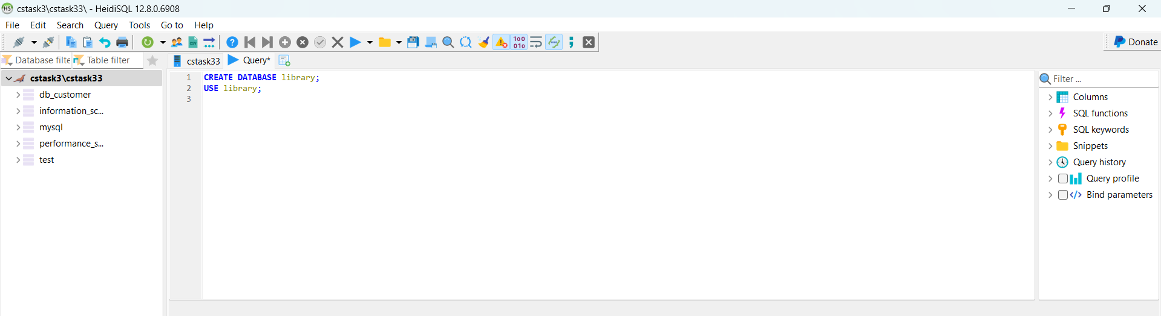

This will create a DATABASE called library.

Step 2:

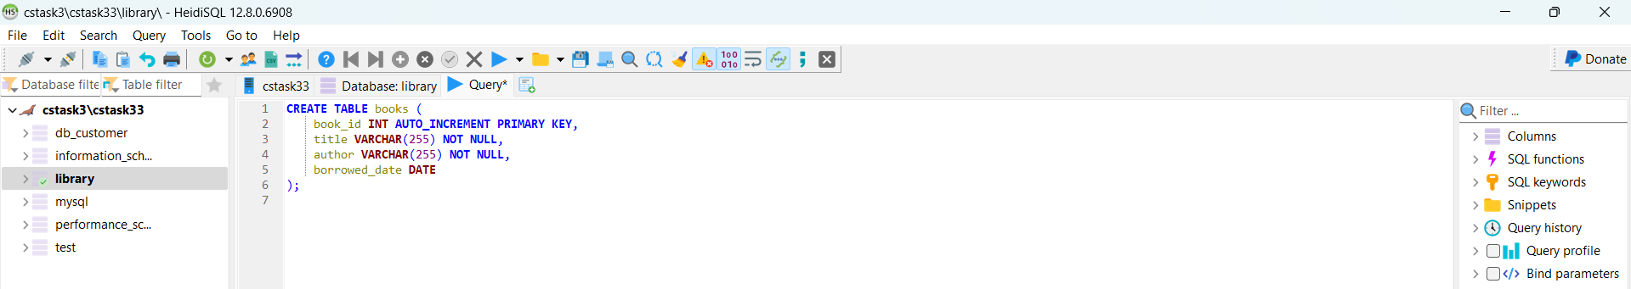

This code will make a table called **books** in a database. The table will keep information about books like book_id, title, author and borrowed date

Step 3:

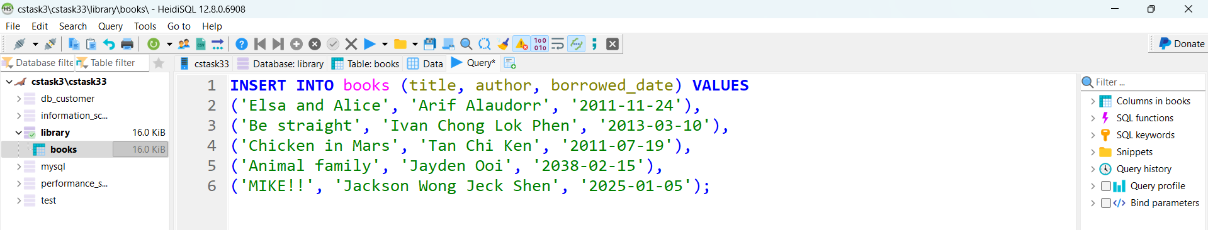

This will make a table like:

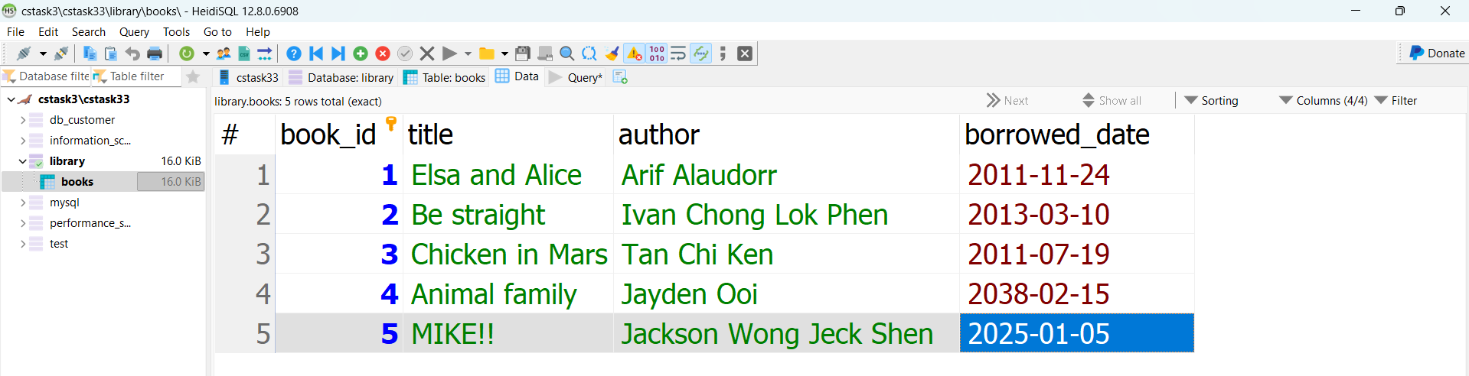

Step 4:

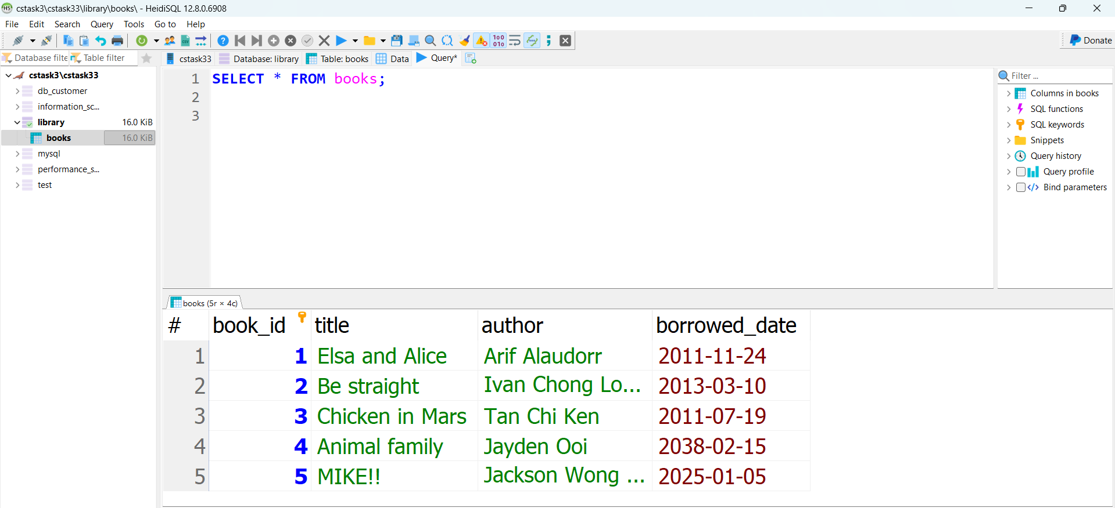

This will list down all the books

Step 5:

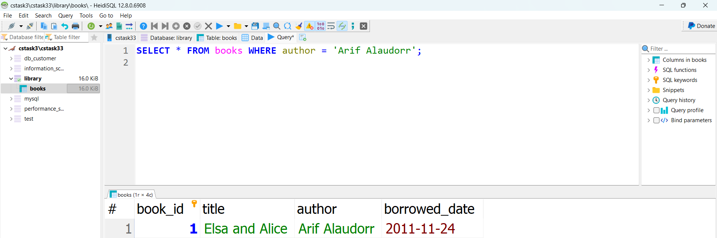

Find books by Author

Step 6:

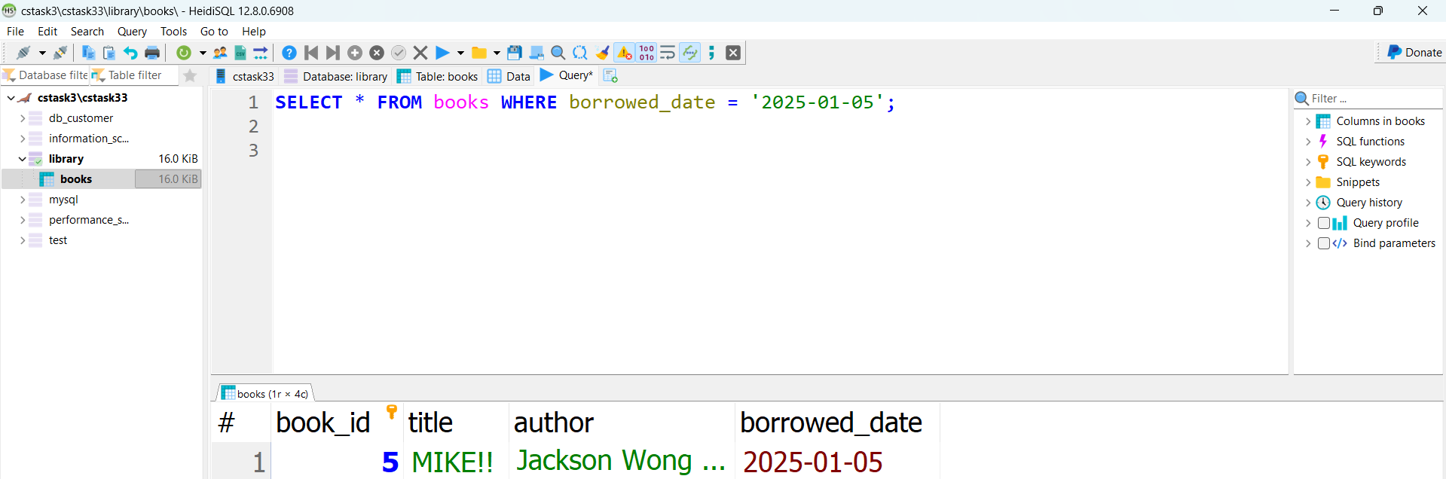

Find book by date

Step 7:

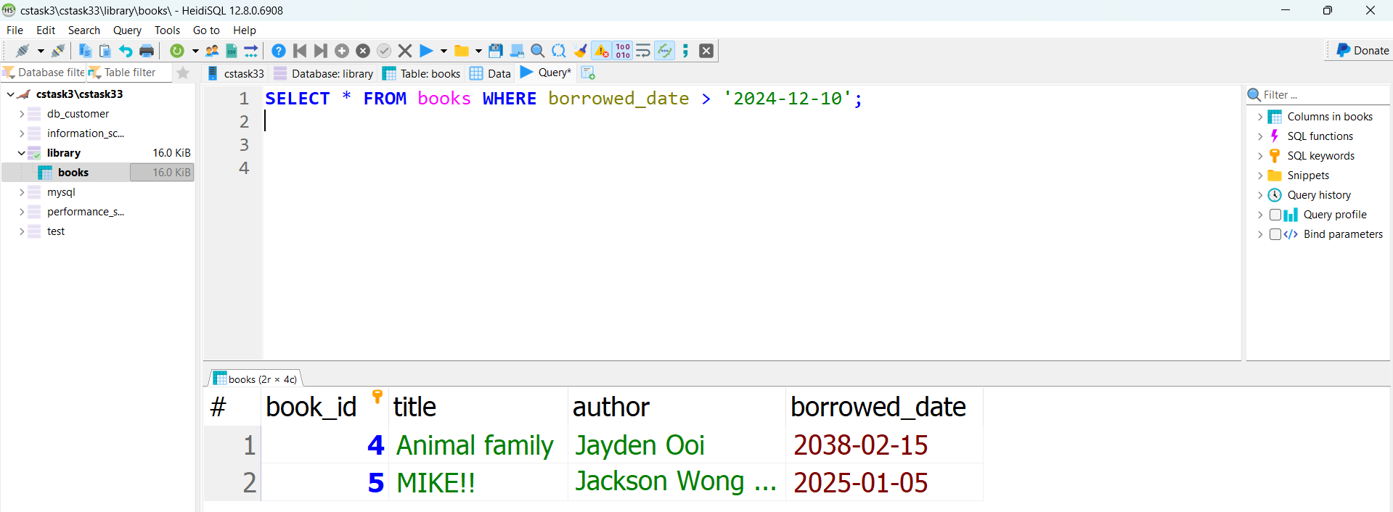

Find book after a specific date

Step 8:

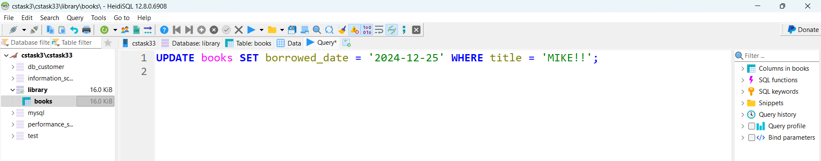

Update the date of a book

Result:

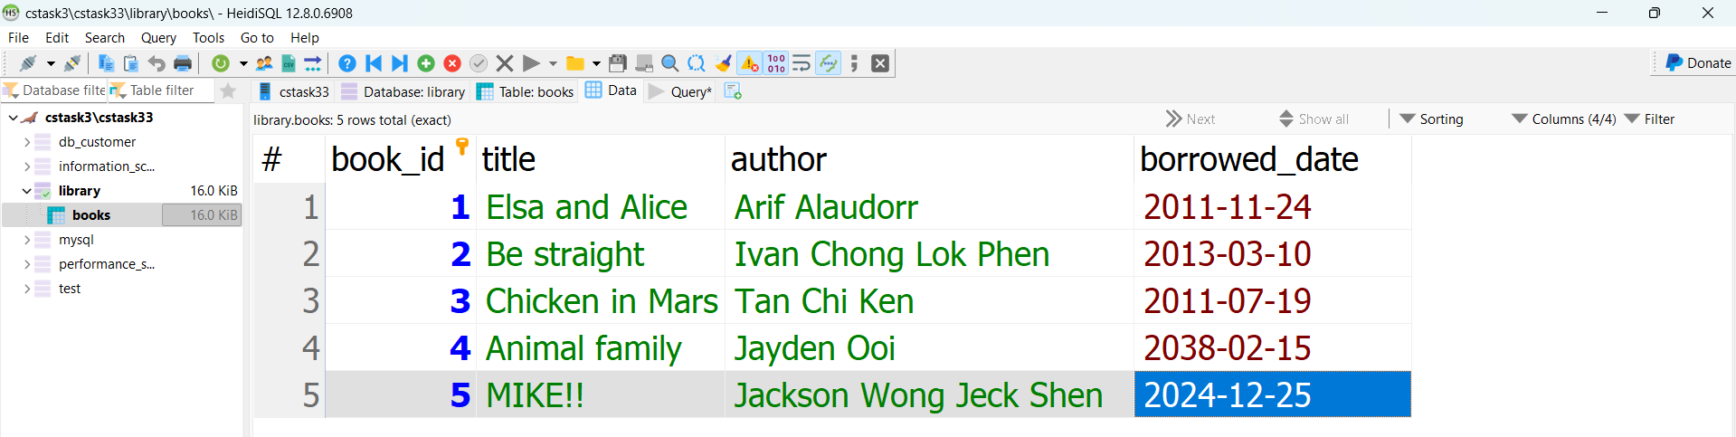

Step 9:

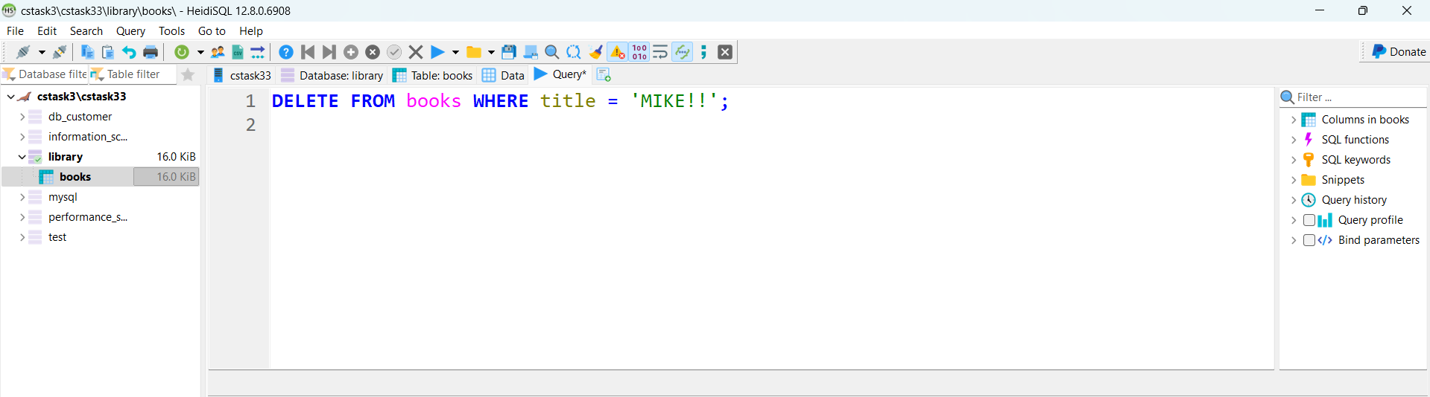

Delete all books that named MIKE!!

Result:

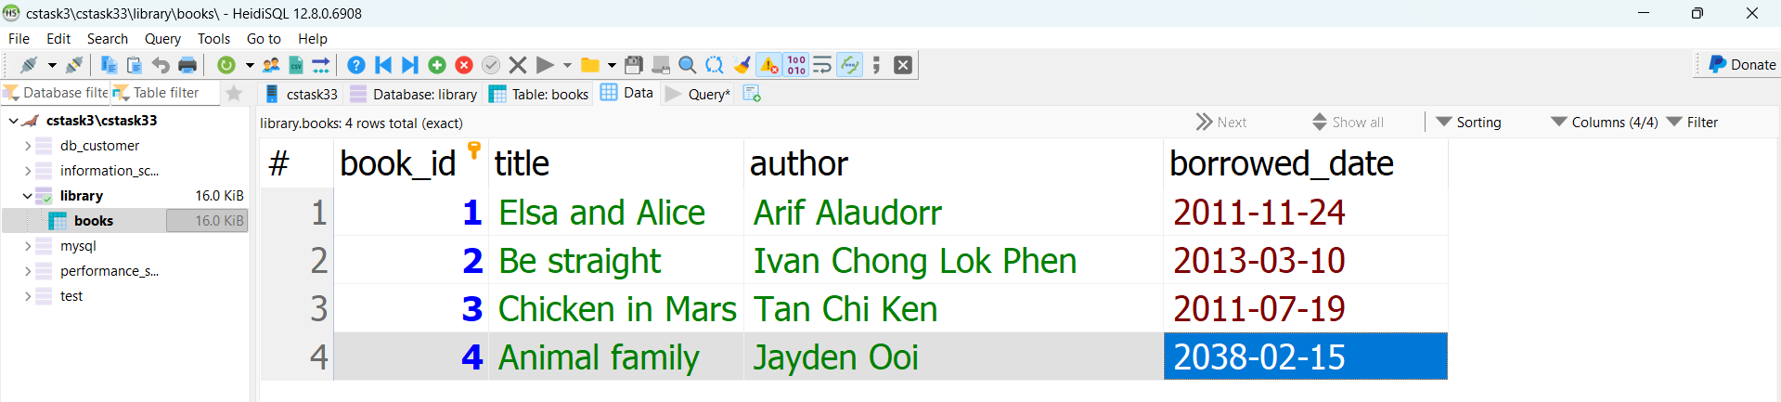

\

Step 10:

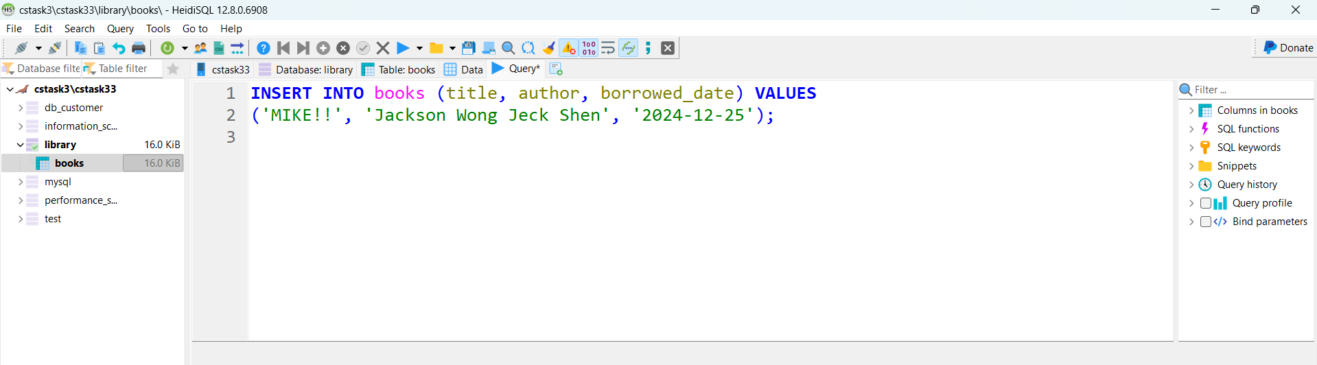

Readd the book that been deleted

Result:

